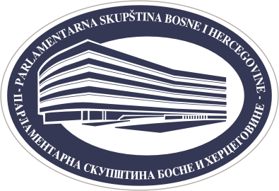

PARLIAMENTARY ASSEMBLY OF BOSNIA AND HERZEGOVINA
PUBLIC RELATIONS SECTOR
www.parlament.ba ● e-mail: press@parlament.ba
phone: + 387 33 284 441
phone /fax: + 387 33 284 447

LIST OF VISITORS OF THE PARLIAMENTARY ASSEMBLY OF BOSNIA AND HERZEGOVINA
Organisation/ Institution:
Date of visit:

No. | Name: | ID number:

